How visible and readable do you feel each of the following are on the Application - [Link](https://app.uizard.io/p/d82ceb8b)

Ranking: / 10



Comments:

Ranking: / 10

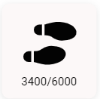

Comments:

Ranking: / 10



Comments:

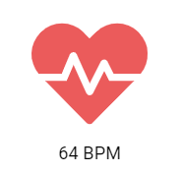

Ranking: / 10

Comments:

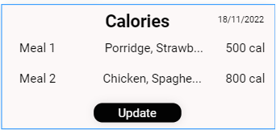

Ranking: / 10

Comments:

Ranking: / 10



Comments: